CH17
- some lipases are regulated by hormones glucagon and epinephrine
Carnitine deficiency. Carnitine acyltransferase deficiency.
Lipid accumulation, hypoglycemia【醫】血糖過少 (reduced gluconeogenesis),
muscle weakness (MCADD 也會低血糖)
via the acyl-carnitine/carnitine (rate limiting step) transporter

fatty acid 長短 4-8 4-14 12-18
B- oxidation FADH2→加水→NADH→+CoA
Odd number fatty acid: prpionyl-CoA(3)→methylmalonyl→succinyl-CoA
Coenzyme: biotin + B12

Pernicious anemia-failure to absorb vitamin B12 from intestine
Reduced production of erythrocytes, levels of hemoglobin,
In blood cell thymidine synthase need B12 dTMP
B12
Synthesized by microorganisms
Intrinsic factor- glycoprotein (stomach)

ACC 會被 PKA AMPK 林酸化 酶活性

peroxisome/glyoxysome
for long chain fatty acid (26:0)
and branched-chain fatty acid

Zellweger syndrome-
lack peroxisome

X-linked adrenoleukodystrophy
(XALD)-no transporter in the
peroxisomal membrane

Plant: no b-oxidation
in mitochondria
in leaf peroxisomes

The omega oxidation
of fatty acid in the ER
(liver and kidney)
MCADD

The a-oxidation
of a branched-chain fatty acid
in peroxisomes
Refsum’s disease:
phytanoyl-CoA hydroxylase

ch21
- Catabolism of fatty acids
  - produced acetyl-CoA
  - reducing power to NADH
  - location: mitochondria
Anabolism of fatty acids
- requires malonyl-CoA and acetyl-CoA
- reducing power from NADPH
- location: cytosol in animals, chloroplast in plants

ACC is a bifunctional enzyme
Biotin carboxylase
Transcarboxylase

生成NADPH Hepatocyte and adipocyte
Malate→malic enzyme→pyruvate; 五碳糖循環

Fatty acid synthesis調控點 citrate lyase + ACC

Aspirin acetylation COX,共價抑制; ibuprofen mimic COX substrate,競爭抑制

Leucotriences: lipoxygenase ( Cyto P450) in sER

Phosphatidic acid 合成在Liver and kidney ( G3P+2次acyl transferase)
→水解phophatase→acyl transfer = TAG
→ + head group = glycerolphospholipid

Regulation of triacylglycerol synthesis by insulin
Reduce cAMP- reduce lipolysis: reduce free fatty acid in blood

Pyruvate / pyruvate carboxylase→ oxaloacetate/ PEPcarboxykinase (PEPCK) →phosphoenolpyruvate→DHAP→glycerol 3-phosphate

In adipocyte: glucagon and epinephrine
Suppress glycolysis
Little DHAP is available
no glycerol kinase No glucose synthesis

Glucocorticoil hormones regulate PEP carboxykinase
In the liver and adipose tissue (cortisol and dexamethasone)
+ PEPCK in liver; - PEPCK in adipocyte → TAG ↑ in blood

Thiazolidinediones-reduce fatty acids in the blood
Increase sensitivity to insulin
+ PEPCK in adipocyte

Anionic phospholipid: cardiolipin(CL) + phosphoinositol 用 strategy 1 ( ...synthase)

In mammals
(no CDP-diacylglycerol and serine
to PS)
Head-group exchange
(PC—PS or PE—PS)
PE-PS / ph~e~-serine transeferase or ph~serine decarboxylase
PE – PC / methytransferase

Phosphatidylcholine in mammals strategy 2

Ether lipid,
Plasmalogen : fattyl-CoA + DHAP ;Head : Ethanolamine;
mix function oxidase: perosisome
platelet-activating factor
Half of the heart
phospholipid

Sphingolipids
2nd big group
Lung surfactant
Mix function oxidase: sER
Ceramide→ cerebroside ( UDP-GlC),glycolipid
→ sphingomyelin( PC )
膽固醇
XXX HMG-CoA → lyase in 粒線體 matrix → acetoneacetate
Reductase in sER → meavlonate ( cholestrol合成) 速率步驟
2*Farnesyl / squalene sythase →squalene
Squalene/ squalene monooxygenase (mix function oxidase in 粒線體)
Cholestrol/ acyl-CoA-cholestrol acyl transferase (ACAT)→ cholestrol ester
In HDL: cholestrol+ PC(lecithin) / LCAT →cholestrol ester
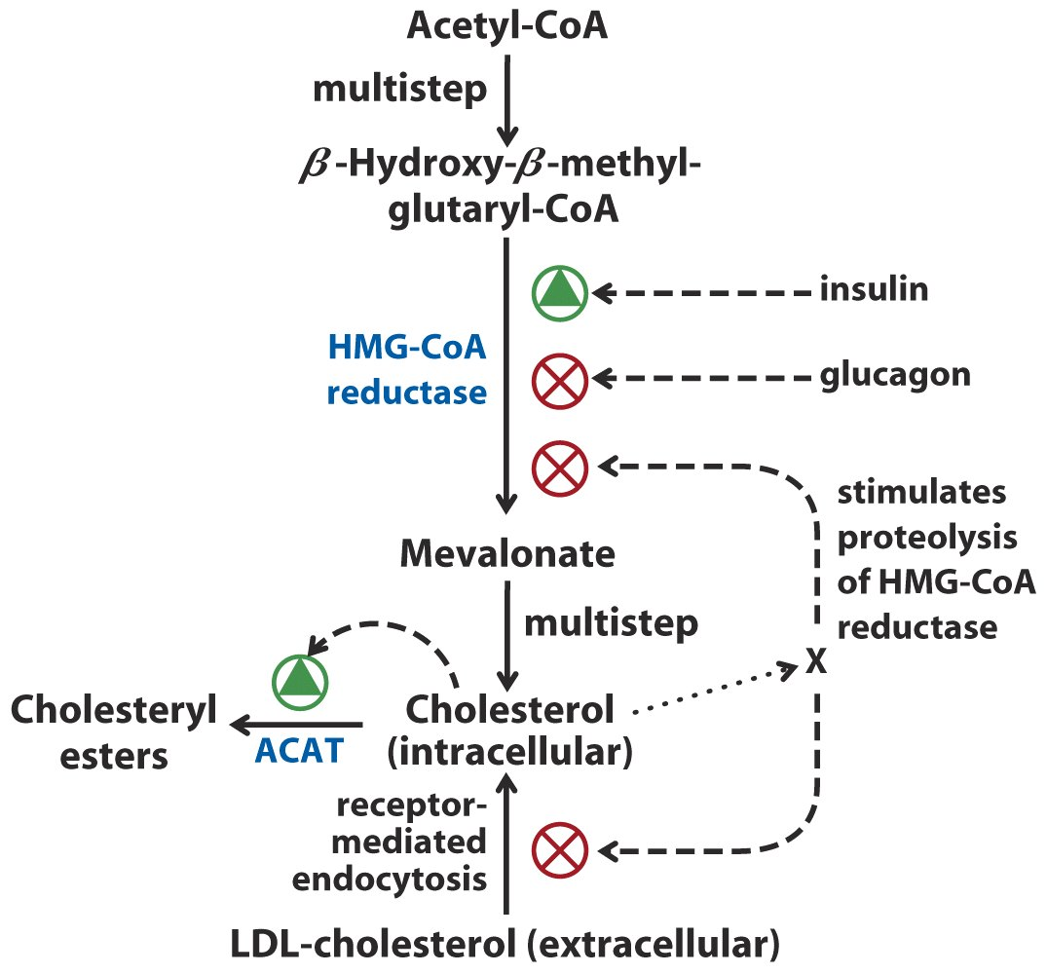
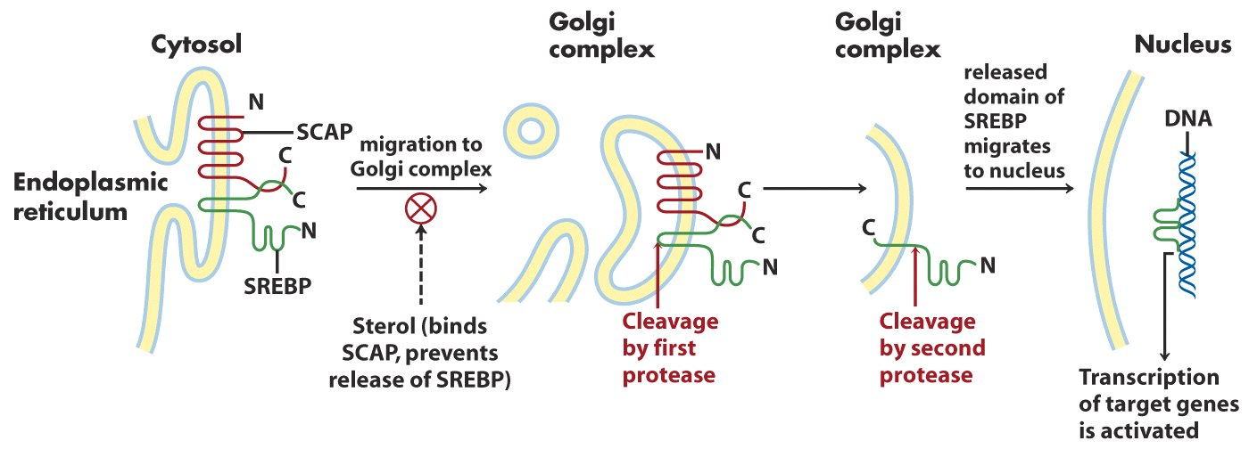
SREBP (sterol regulatory element-binding protein) activation
SCAP: SREBP cleavage-activating protein—
binds to cholesterol and other sterols
affect HMG CoA reductase + LDL receptor

statin Competitive inhibition of HMG-CoA reductase
Cholestyramine-resin binds to bile acids -prevent reabsorption

Cholestrol 的 steroid hormone合成 by mix fuction oxidase (p450)
在Adrenal cortex mitochondria Hydroxylation and cleavage

